**Supporting Information**

For

**Exciton Diffusion and FRET in Dye-doped Conjugated Polymer Nanoparticles**

Louis C. Groff, Xiaoli Wang, and Jason D. McNeill

1. **Preparation and Characterization of Conjugated Polymer Nanoparticles (CPNs)**

The copolymer poly[(9,9-dioctylfluorenyl-2,7-diyl)-*co*-(1,4-benzo-{2,1',3}-thiadiazole)] (PFBT, MW 10,000, polydispersity 1.7) was purchased from ADS Dyes, Inc. (Quebec, Canada). The fluorescent dye perylene red (Exalite 613) was purchased from Exciton (Dayton, OH). The fluorescent dye fluorescein was purchased from Invitrogen (Eugene, OR). The solvent tetrahydrofuran (THF, anhydrous, 99.9%) and sodium hydroxide (SigmaUltra, minimum 98%) were purchased from Sigma-Aldrich (Milwaukee, WI). All chemicals were used without further purification. Preparation of the fluorescent nanoparticles was performed using a previously described reprecipitation method.1 The copolymer PFBT was dissolved in THF by gentle agitation and prepared at a concentration of 1000 ppm. Perylene red was dissolved in THF by gentle agitation and prepared at a concentration of 100 ppm. The solution was further diluted to 2 ppm for doping. Varying amounts of the dopant perylene red solution were mixed with the PFBT solution to produce solution mixtures with a constant concentration of 20 ppm PFBT and dopant/host fractions of 0 to 2 wt% perylene red. The mixtures were sonicated very briefly to ensure homogeneity. A 2 mL quantity of each solution mixture was added rapidly to 8 mL of deionized water under sonication. THF was removed from the resulting nanoparticle suspensions by partial vacuum evaporation and subsequently vacuum filtered through a glass fibre prefilter to remove larger aggregates and a 0.1 µm PTFE membrane filter. The resulting nanoparticle suspensions are clear (not turbid) and stable for months with no visible signs of aggregation.

Size distributions and morphologies of undoped and perylene red doped PFBT nanoparticles were determined by atomic force microscopy (AFM). Samples were prepared by functionalizing the surface of a freshly cleaned glass coverslip with 3-aminopropyl-trimethoxysilane in anhydrous ethanol, followed by dipcasting in a diluted nanoparticle suspension for 40 minutes, then removing the coverslip and allowing it to dry overnight in an enclosed environment. Surface topographies were measured on an Ambios Q250 multimode AFM in tapping mode. As shown in Figure 1 in the main text, the mean diameter of the CPNs was 8 ± 2 nm. All of the perylene red doped PFBT CPN samples showed no substantial changes in mean diameter, with a similar size distribution.

UV-Vis absorption spectra were collected on a Shimadzu UV2101PC scanning spectrophotometer using 1 cm quartz cuvettes. Fluorescence spectra were collected and fluorescence quantum yield was measured using a commercial fluorimeter (Quantamaster, Photon Technology International, Inc.) using 1 cm quartz cuvettes. The UV-Vis spectra showed no variations from the undoped spectrum over the range of doping, and the absorbance of perylene red was well below the limit of detection of the instrument in the CPN suspensions. The fluorescence spectra of the CPN samples are given in Figure 2 in the main text.

1. **Fluorescence Quantum Yield**

The standard fluorescent dye fluorescein in 0.01 M sodium hydroxide was utilized to determine the fluorescence quantum yield of the PFBT CPN samples. 473 nm was selected as the excitation wavelength. The concentrations of the standard and nanoparticle suspensions were adjusted to yield an absorbance of ~0.05 at 473 nm. The absorbance, integrated fluorescence, and refractive indices of the sample and standard solutions were used in conjunction with the literature value of 0.92 for the quantum yield of fluorescein in 0.01 M sodium hydroxide to calculate the fluorescence quantum yield of the nanoparticle suspensions.2 The results of the quantum yield measurements are given in Figure 2 in the main text.

The change in quantum yield upon removing oxygen from the undoped PFBT CPN samples was also measured. Samples were purged with nitrogen in the dark for 45 minutes prior to measurement. The quantum yield in air was measured to be 0.097, and 0.100 in nitrogen. The differences in quantum yield for the sample in air compared to the data in Figure 2 is owed to batch-to-batch variability in the CPNs. Nevertheless, the quantum yield results indicate that the brightness of the CPNs is insensitive to oxygen removal.

1. **Picosecond Time-Correlated Single Photon Counting (TCSPC) Spectroscopy**

Fluorescence lifetimes were measured in air using time-correlated single photon counting (TCSPC) spectroscopy. The second harmonic (420 nm) of the output of a mode-locked Ti:Sapphire laser (Coherent Mira 9000, ~100 fs pulses) was used to excite the samples. The output of a fast PIN diode (Thorlabs DET210) monitoring the pulse shape was used as the start pulse for a time-to-amplitude converter (TAC, Canberra Model 2145). The laser output incident on the PIN diode was attenuated until the output voltage of the PIN diode read 200 mV. Nanoparticle fluorescence was collected perpendicular to the excitation source after passing through a 460 nm long pass filter for the undoped nanoparticles. An additional 540 ±10 nm band pass filter was added for the doped samples in order to filter out the emission from perylene red. For the measurement of acceptor lifetimes, a 600 nm long pass filter was added in place of the 540 ± 10 nm band pass filter to remove the emission from PFBT. The emission was detected by a single photon avalanche photodiode (APD, Perkin-Elmer, SPCM-AQR). The output of the APD was used as the stop pulse for the TAC. The excitation pulse was attenuated to maintain a count rate ~6 kHz. The analog signal from the TAC was digitized using a multichannel analyzer (FastComTec, MCA-3A). Before and after each fluorescence lifetime measurement, the instrument response function (IRF) was measured using scattered laser light from a dilute suspension of polystyrene microspheres. The width of the resulting IRF was ~80 ps (FWHM).

The effect of removing oxygen from the nanoparticle samples on the lifetime was also assessed by purging the undoped PFBT CPN samples with nitrogen. The bi-exponential weighted average lifetimes of the undoped PFBT CPNs were measured to be 780 ps in air and 850 ps in nitrogen. Again, the differences from the results in text are due to batch-to-batch variability in the CPN samples. Regardless, this shows that the lifetime is relatively insensitive to oxygen removal.

In addition to the lifetimes of the host polymer PFBT, the lifetimes of the acceptor perylene red were measured. The lifetime of perylene red in THF was measured to be 5.4 ns, which is consistent with the literature.3 The moderate to heavily doped samples of PFBT nanoparticles were selected due to the relatively low contribution to the emission signal by PFBT as well as to assess the effect of the observed self-quenching of perylene red on its lifetime in the nanoparticles. The lifetime of perylene red doped within the nanoparticles was found to be reduced to 3.1 ns, and follows a decreasing trend as doping increases. The reduction in lifetime indicates that perylene red is dynamically self-quenched.

|  |  |
| --- | --- |
| **Perylene Red %(w/w)** | **τexp (ns)** |
| **THF** | 5.4 |
| **1.0%** | 3.1 |
| **1.5%** | 2.9 |
| **2.0%** | 2.6 |

1. **Exciton Diffusion/Energy Transfer Model**

We previously developed a Monte Carlo approach to modeling the combined effects of exciton diffusion and energy transfer in CPNs, which yielded values for energy transfer efficiency that were in agreement with experimental results for dye-doped CPNs.[4](#_ENREF_4" \o "Wu, 2008 #9) This approach was also applied to modeling fluctuations in the fluorescence centroid of a single CPN.[5](#_ENREF_5" \o "Yu, 2012 #1040) Here, we have modified the previous simulation code to provide kinetics information for comparison to the time-resolved fluorescence results. We have also modified our approach to explicitly account for quenching by defects. The simulation algorithm is described briefly as follows (additional simulation details are provided in the Supporting Information). Dopant dyes and/or defects are distributed randomly within the nanoparticle, represented by a sphere. An initial population of excitons is also distributed randomly within the sphere. For each time step *t*, each exciton is propagated by adding to its position along each axis a Gaussian random number scaled so that *2=2Dt*, where *D* is the (1D) diffusion constant and *2* is the variance of the random number distribution. Then the energy transfer rate for each exciton to each dopant or defect is calculated based on the exciton-acceptor distances and the conventional Förster rate expression. Based on the rates of energy transfer, radiative decay, and non-radiative decay, the probability of decay or transfer for a given exciton during the time step is calculated and compared to a random number to determine the exciton fate. The exciton population is updated accordingly, and recorded for each time step. The simulation continues until nearly all of the exciton population has decayed. The simulations are performed for many initial random configurations of acceptors and excitons, and the exciton population kinetics and energy transfer efficiencies are calculated from the simulation results.

We explicitly include exciton quenching by defects as a key feature in our approach to modeling exciton diffusion and energy transfer in the nanoparticles. The explicit inclusion of quenching by defects is based on several observations. First, the fluorescence quantum yield (c.f. Fig. S1) and excited state lifetime of the nanoparticles is greatly reduced ( = 0.14,  = 800 ps) as compared to the polymer in a good solvent such as THF ( = 0.66,  = 3000 ps). The phenomenon of reduced lifetimes in the aggregated state is often observed in J-aggregates, and is typically described as due to coupling of the transition dipole moments that causes a large increase in the radiative rate.6 However, strong J-aggregate-type coupling is not likely in the present case, since little shift in the absorption spectrum is observed upon nanoparticle formation (c.f. Fig. S1). Furthermore, the radiative rate, estimated from the lifetime and quantum yield values, is actually somewhat lower in the nanoparticles (1.8x108 s-1), as compared to the polymer in THF (2.2x108 s-1), which does not correspond to typical J-aggregate behavior. Finally, the heterogeneity of the excited state lifetime of the nanoparticle is increased (*ß* = 0.65) as compared to the free polymer in solution (*ß* = 1.0), consistent with quenching by energy transfer to defects or other quenching species. Further support for the defect-quenching hypothesis is given in the results of exciton diffusion-energy transfer simulations, discussed below.

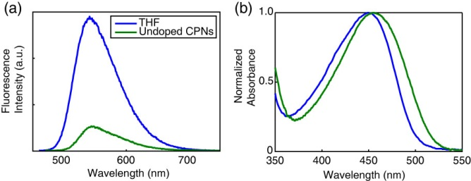

**SI Fig. 1.** (a) Fluorescence spectra and (b) normalized absorbance spectra of PFBT in THF (blue) and undoped PFBT CPNs (green).

Preliminary simulation results (c.f. SI Fig. 2) indicate that the use of the random walk algorithm in the absence of defect quenching was found to be insufficient to adequately match experimental lifetimes and beta values of perylene red doped PFBT CPNs despite matching experimental quenching efficiencies well. In order to better match simulated results to experiment, the Poisson distribution of defects dyes has also been implemented into the model. This is accomplished by calculating the probabilities of a series of dyes and defects being present within the nanoparticle ,Where  is an integer value of either dyes or defects per nanoparticle and  is the mean number of dyes or defects per nanoparticle. The total probability for a each average dye/defect pair is calculated by the product of the individual dye and defect probabilities summed over all likely  and . The data resulting from the exciton diffusion simulations was interpolated and utilized to calculate the quenching efficiency, lifetime, and beta. These were calculated for each average dye/defect combination by summing  and using the interpolated simulation data at a value of (+1). The quenching efficiency for a given sample was then determined by a Poisson weighted average over all likely combinations of  and . The interpolated lifetime and beta were utilized with Equation 4 and the total probability at all likely combinations of  and  to generate a Poisson weighted fluorescence decay trace for each average dye/defect combination. The decay trace was fit by nonlinear least squares minimization to bi-exponential and KWW functions. The results of the corresponding fits were subsequently compared to experimental TCSPC results (Fig 4 in main text).

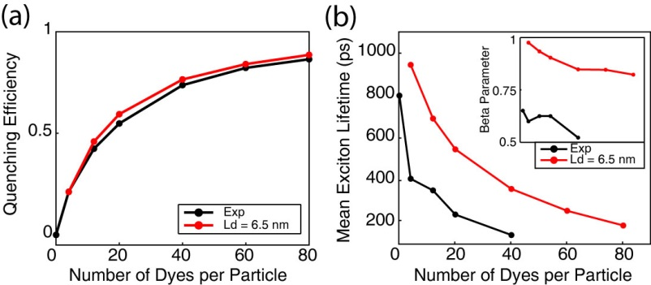

**SI Fig. 2.** Exciton diffusion simulation results ignoring quenching by defects and Poisson statistics. (a) Simulated (red) and experimental (black) quenching efficiency, (b) mean exciton lifetimes, and beta (inset) as a function of dyes per nanoparticle for a particle radius of 12 nm.

Results of exciton diffusion simulations (c.f. SI Fig 3) indicate that an increase in either LD or R0 results in an increase in quenching efficiency. As such, matching simulated and experimental quenching efficiencies alone is insufficient to separate the individual contributions of exciton diffusion and energy transfer in this system. The simulated lifetimes are directly proportional to (1-QE), as expected. While an exact function is not known in order to calculate beta directly from the simulated LD and R0, simulation trends indicate that beta is directly proportional to LD and inversely proportional to R0. Thus, beta is proportional to the ratio of LD/R0.

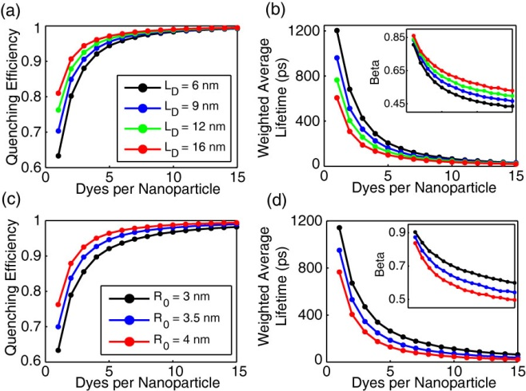

**SI Fig. 3.** Initial exciton diffusion simulations for a 4 nm particle radius. (a,b) Quenching efficiency, bi-exponential weighted average lifetime, and beta (inset) vs. dyes per nanoparticle for LD = 6 nm (black), 9 nm (blue), 12 nm (green), and 16 nm (red). (c,d) Quenching efficiency and bi-exponential weighted average lifetime, and beta (inset) vs. dyes per nanoparticle for R0 = 3 nm (black), 3.5 nm (blue), and 4 nm (red).

**References for Supporting Information**

(1) Szymanski, C., Wu, C. F., Hooper, J., Salazar, M. A., Perdomo, A., Dukes, A., and McNeill, J. *Journal of Physical Chemistry B* **2005**, *109*, 8543.

(2) Weber, G.; Teale, F. W. J. *Transactions of the Faraday Society* **1957**, *53*, 646.

(3) Al-Kaysi, R. O.; Ahn, T. S.; Muller, A. M.; Bardeen, C. J. *Phys Chem Chem Phys* **2006**, *8*, 3453.

(4) Wu, C. F., Zheng, Y. L., Szymanski, C., and McNeill, J. *Journal of Physical Chemistry C* **2008**, *112*, 1772.

(5) Yu, J., Wu, C. F., Tian, Z. and McNeill, J. *Nano Lett* **2012**, *12*, 1300.

(6) Kometani, N.; Nakajima, H.; Asami, K.; Yonezawa, Y.; Kajimoto, O. *Journal of Physical Chemistry B* **2000**, *104*, 9630.